**Supplementary Materials**

Title Interfacial-Redox-Induced Tuning of Superconductivity in YBa2Cu3O7-δ

Short Title: Interfacial Tuning of Superconductivity in YBCO

**Authors**

Peyton D. Murray, Dustin A. Gilbert, Alexander J. Grutter, Brian J. Kirby,

David Hernandez-Maldonado, Maria Varela, Zachary E. Brubaker, Rajesh V. Chopdekar, Valentin Taufour, Rena J. Zieve, Jason R. Jeffries, Elke Arenholz, Yayoi Takamura,

Julie A. Borchers, Kai Liu

The nuclear SLD profiles presented in Fig. 4 of the main text correspond to the models which best fit the specular reflectivities of the as-grown and Gd-capped samples measured at 6K, shown in Fig. S1. The non-spin-flip reflectivities of the as-grown and Gd (3 nm and 7 nm) YBCO samples show minimal spin asymmetry, indicating that little to no magnetism is present in either the YBCO or the Gd layer, even without fitting. Thus, the possibility of magnetic proximity effects playing a role in the suppression of superconductivity of these samples can be ruled out. The Gd (20 nm) profile shows slight spin splitting, suggesting that the thick Gd capping layer may contribute a small component to the magnetic SLD.

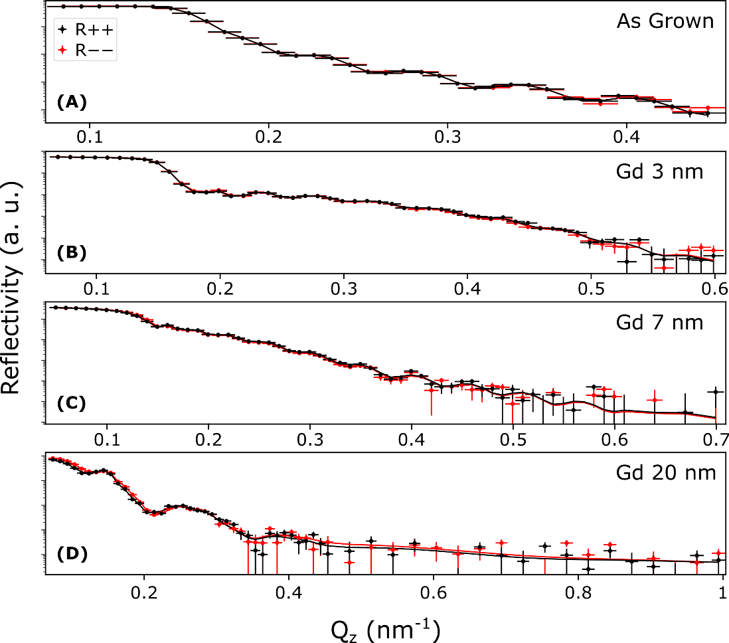

**Fig. S1.** **Neutron reflectometry profiles.** Specular neutron reflectivities of the non-spin-flip channels ( $R++$ and $R--$) shown as a function of scattering vector $Q_{Z}$ for (**A**) the as-grown, (**B**) Gd (3 nm), (**C**) Gd (7 nm), and (**D**) Gd (20 nm) samples. In all panels, symbols denote experimental data with uncertainty, with fits corresponding to the models from Fig. 4 of the main text shown as red and black lines.